Stage 7 – Mad Caboose
COURSE DESIGNER: Ike Starnes

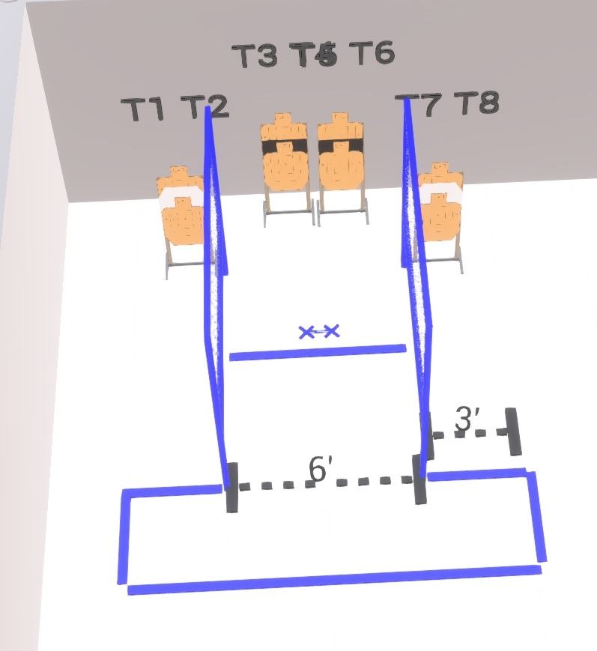

Written Stage Briefing:

Stage 7 – Mad Caboose - is a 8 round, 40 point, Virginia Count Course. There are 8 cardboard targets

Start position is feet on Xs, facing downrange
Handgun is loaded and holstered, wrists below belt
PCC is loaded, stock touching belt

On the audible start signal, engage targets from within the shooting area with only 1 round each using weak hand / weak shoulder only.

USPSA / NROI Range Commands:
- Make Ready
- Are you ready?
- Standby
- If finished, unload and show clear
- If clear, hammer down and holster (Handgun)
If clear, hammer down and flag (PCC)
If clear, cylinder closed and holster (Revolver)
- Range is clear

Setup Notes:
4 Single Wall Stands
2 Full Walls
4 Target stands / 8 target sticks
1 Xs



